

SCHOOL *of* BUSINESS AND TECHNOLOGY

Department of Engineering and Aviation Sciences

Design of a Smart American Sign Language Translator

**Josheb Dayrit**

Advisor: Dr. Zhang

Spring 2020

**Table of Contents**

1. Abstract 7

2. Introduction 8

**2.1** Aims 9

**2.2** Design Requirements 13

**2.3** Design Constraints 13

**2.4** Design Method 15

3. Project Description 16

**3.1** System Description 16

**3.2** System Diagram 16

4. Implementation Plan 17

**4.1** Tasks 17

**4.2** Timeline/Milestones/Delivery Plan 18

5. Implementation 19

**5.1** Implementation of Task 1 19

5.1.1. Implementation of Subtasks 1 and 2 19

5.1.2. Implementation of Subtask 3 27

**5.2** Implementation of Task 2 29

5.2.1. Implementation of Subtask 1 29

5.2.2. Implementation of Subtask 2 36

5.2.3. Implementation of Subtask 3 45

**5.3** Implementation of Task 3 46

5.3.1. Implementation of Subtasks 1 and 2 46

5.3.2. Implementation of Subtask 3 47

**5.4** Implementation of Task 4 63

5.4.1. Implementation Flowchart 63

5.4.2. Implementation Overview 63

**5.5** Implementation of Task 5 64

5.5.1. Implementation Flowchart 64

5.5.2. Implementation Overview 65

**5.6** Implementation of Task 6 66

5.6.1. Preliminary Considerations 66

5.6.2. Deciding on GUI Design 67

5.6.3. Programming the GUI 68

6. Conclusion 71

7. Acknowledgements 73

8. Appendix 74

**8.1** Source Code 74

8.1.1. Source Code for GUI 74

8.1.2. Source Code for Data Logger 74

8.1.3. Source Code for Speech-to-Text Module 74

8.1.4. Source Code for Text-to-Speech Module 74

8.1.5. Source Code for Interfacing with Neural Network 74

9. References 75

**List of Figures**

Figure 1: Rates of employment in 2014 (deaf vs non-deaf) 10

Figure 2: The system diagram of Sign AI 16

Figure 3: EMG sensor modules in Myo armband 20

Figure 4: Invensense MPU-9150 on the back of the motherboard 20

Figure 5: Processor for Myo armband 20

Figure 6: Setup for each sensor 21

Figure 7: Accuracies of 2 models for each EMG device 22

Figure 8: Hyperplanes in an SVM model 23

Figure 9: The data-logging algorithm 26

Figure 10: The data-formatting algorithm 28

Figure 11: ASL for “try” (final hand position) 30

Figure 12: ASL for “rock” (final hand position) 30

Figure 13: Gaussian noise applied to image 32

Figure 14: Salt-and-pepper noise applied to clear image 32

Figure 15: An imaging radar at work 33

Figure 16: Water droplets captured in an image 34

Figure 17: A filter tuned for detecting curves in an image 38

Figure 18: Dot product of the receptive field and filter 38

Figure 19: Design of Bheda and Radpour’s ConvNet 40

Figure 20: A simple RNN layer 41

Figure 21: The cell state, highlighted in a diagram of san LSTM layer 42

Figure 22: The “gates,” denoted by a lowercase sigma (σ) 42

Figure 23: “Forget” gate, highlighted in a diagram of an LSTM layer 44

Figure 24: “Update” gate, highlighted in a diagram of an LSTM layer 44

Figure 25: “Output” gate, highlighted in a diagram of an LSTM layer 44

Figure 26: The architecture of the finalized neural network 57

Figure 27: Comparing the accuracy of the neural network in 2 datasets (train and test) 57

Figure 28: Comparing the accuracy of the neural network in 2 datasets (train and test) 58

Figure 29: Flowchart of Gesture-to-Speech Algorithm 63

Figure 30: Flowchart of Speech-to-Text Algorithm 64

Figure 31: Preliminary design of the GUI 68

**List of Tables**

Table 1: Predicted timeline for tasks 18

1. Abstract

Physical disabilities can prevent the people from immersing themselves in everything society has to offer. Deafness in particular has a significant impact on a person’s life in that it prevents one from communicating through speech. Studies show that deaf person are less likely to make use of medical services and are more prone to psychological disorders, disorders likely stemming from the difficulty of forming meaningful connections with hearing counterparts [1], [2]. There have also been recorded instances of discrimination in the employment due to physical disabilities, including deafness [3]. In the case of deafness, communication with others is the overarching issue, bringing with it a deluge of inevitable side-effects. This paper seeks to develop a translation tool which relies on the training a neural network for the purpose of recognizing different ASL (or American Sign Language) gestures.

1. Introduction

The following project seeks to develop an ASL (American Sign Language) translation tool for deaf persons. It will be hosted on a computer or microcomputer like the 32-bit Raspberry Pi. A deep learning model will be trained to recognize ASL through pre-processed EMG (electromyography) data and orientation data in the form of quaternions, all acquired by the Myo armband by Thalmic Labs. Each part in the development process is crucial – doubly so for the deep learning model, which is in charge of gesture classification.

As far as hardware is concerned, an LCD (liquid crystal display) will be used to print all speech outputs. After all, communication is a two-way street. Alternatively, a GUI can be developed to display outputs instead. Interfacing with the LCD is a speech-to-text software, which passes data for the LCD to display. When used in conjunction with the neural network, the LCD presents users with the missing part: understanding of speech. The end product, tailor-made for the deaf population, is expected to offer a “sign” and “listen” functionality, whereby deaf users can sign and listen through a mixture of software and hardware.

For Sign AI, ease of use as well as translation accuracy are of utmost importance. Ease of use is incorporated in the design process through accessories which increase portability and convenience by virtue of being small, little, and therefore easy-to-carry. Meanwhile, translation accuracy hinges on the deep learning model and its ability to differentiate between different types of EMG data. In the end, what Sign AI aims to offer is a reliable ASL translator that creates a user-friendly experience by automating the translation process, which is gesture-by-gesture. Everything is done in the backend and little input is required from the user.

## Aims

Different means of communication have existed since time immemorial. While speech stands as the most common mode of communication, people communicate through writing as well. Unique modes of communication, serving their own specialized purposes, are as plenty as they are ubiquitous. In technology, computers use a scheme of 0s and 1s to perform complicated tasks; in nature, all scores of animals are able to encode meaning in the noises they produce. For modern humans, speech has been intrinsic to communication. However, for ancient humans, it is different. They used a primitive language based around meaning-filled gestures. In a paper titled “The Origin of Human Multi-Model Communication,” two researchers (Stephen Levinson and Judith Holler) from the Max Planck Institute for Psycholinguistics and Donders Centre for Brain, Cognition and Behavior stated that “the modern human communication system is, on a biological time scale, a recent innovation” [4]. Citing the Gestural Theory of Language Origin, Levinson and Holler have much reason to believe that the initial humans (the “cavemen,” or Homo troglodytes) initially employed a gesture-based language.

In a society that communicates through speech, it will be difficult for deaf persons to interact with their non-deaf peers. According to the Gallaudet Research Institute, in the year 2006, “nearly 10,000,000 persons (Americans) are hard of hearing and close to 1,000,000 are functionally deaf” [5]. This is also corroborated by more recent 2012 statistics from the Center of Disease Control and Prevention (CDC), which state that “approximately 15% of American adults (37.5 million) aged 18 and over report some trouble hearing” [6]. While the CDC clarifies that “the overall annual prevalence of hearing loss (has) dropped slightly” with the passing of time (from 16% in 1999 to 14% in 2012), additional findings from the National Deaf Center on Post-Secondary Outcomes reveal an alarming truth about deafness: “In 2014, only 48% of deaf people were employed, compared to 72% of hearing people” [3].

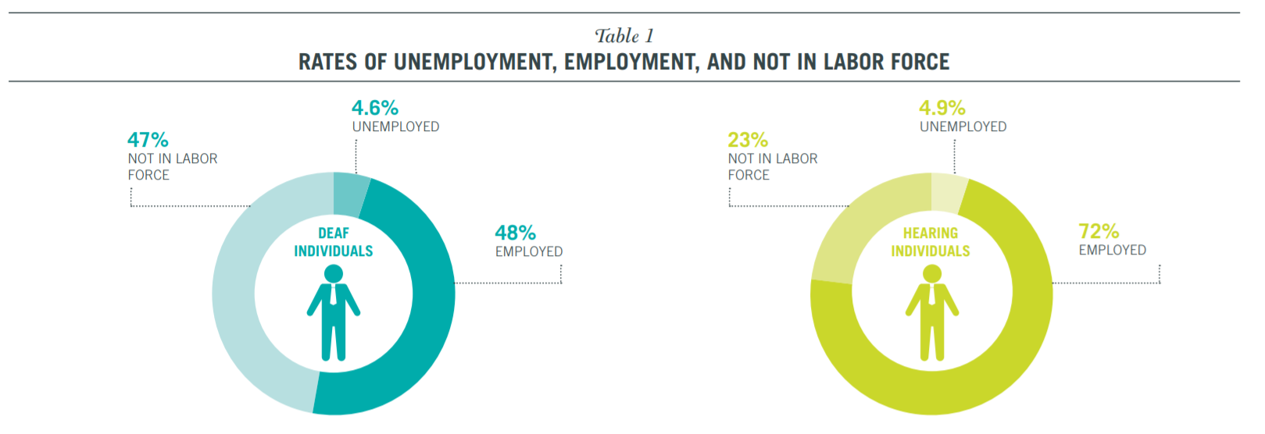

Figure 1: Rates of employment in 2014 (deaf vs non-deaf) [3]

s

Unfortunately, disparities in opportunities and (to some extent) outcomes are due in large part to physical disabilities, as shown by the countless statistics on deaf people. Since deaf people are not capable of speech, they choose to communicate through gesture-based languages, such as American Sign Language (ASL). Because of this, however, prospects for work are limited for deaf people. The harsh reality is that many employers are unwilling to hire deaf employees. While the ADA (American Discrimination Act) outlaws discriminatory practices based on race, gender, or disability, it does not prevent them entirely. In an American study which closely scrutinized successful discrimination lawsuits made against companies, the EEOC (Equal Employment Opportunity Commission) concluded that “young people who are deaf or hard of hearing may be advised to anticipate some resistance from employers” [2].

As outrageous as it sounds, even if a deaf candidate applies for a position while possessing qualifications that meet or exceed a company’s standards, the factor that determines their employment is whether or not they require excessive accommodation. From a corporate perspective, hiring employees who will only place undue burden on a company and its resources is generally not worth the cost. This idea also aligns with the EEOC’s secondary conclusion, which states that disabled applicants who “articulate well their qualifications” and provide long-term work-arounds or solutions to their disabilities are “more likely than others to find success in the world of work.”

One solution that Sign AI brings to the table is the function of a basic, real-time, AI-based ASL translation tool. The inability to speak properly is one disadvantage of deaf persons that either prevents them from fully pursuing specific career paths or leads them to be unjustifiably discriminated against in their search for employment. This inability stems from the fact that speech is a product of both the ears and the mouth; the mouth produces the sounds, while the ears regulate them. Without coordination from both the mouth and ears, it becomes increasingly difficult to produce intelligible speech. Many non-deaf employers simply do not have the time to learn sign language for their deaf applicants. In the hiring process, most are likely to turn their attention to the non-deaf candidates, even if the deaf candidates have the necessary qualifications. Such discrimination is, by all accounts, unfair. However, there is some wisdom to be found in it, even if morally questionable. All businesses are utilitarian in that their goal is to maximize productivity while minimizing expenditure of any sort (human, financial, etc.). If a prospective employee demands more from a company than their fellow competitors, that company will likely settle for those competitors in hopes of making things easier on themselves. While Sign AI cannot shift this mindset, it can address the most prominent disadvantage encumbering deaf persons when competing with their non-deaf peers.

As stated before, while deaf people face many barriers of entry regarding employment, communication is by far the most pressing issue. In the workplace, collaboration among employees is important. Typically, company projects are completed not by a single person, but by teams of people making collective contributions. A pre-requisite to effective collaboration is effective communication, especially in the nascent stages of a project, during which first impressions are gathered, and ideas are put forth for evaluation by others. For deaf persons, communication frequently comes in the form of sign language. Deaf persons have a hard time expressing their ideas to non-deaf persons, because sign language is fundamentally different from spoken language. To bridge the gap between sign language and spoken language, a linguistic interface is needed between the two languages to translate one to the other. Sign AI strives to fulfill this role through a trained AI, a text-to-speech feature that will speak out the meaning of various ASL gestures, and a speech-to-text feature that will convert spoken word back to text.

## Design Requirements

1. The final product is a gesture-based translator, providing translation for each gesture performed.
2. The final product can translate a total of 100 gestures.
3. The final product can differentiate between gestures with a minimum accuracy of 70 percent.
4. The final product will have gesture-to-speech and speech-to-text capabilities.
5. The final product will have an LCD to display speech-to-text outputs.

## Design Constraints

Although design constraints are few in number due to the “hands-off” nature of an AI project, undoubtedly, they do exist. One constraint lies in the ASL language itself, while others in hardware.

1. **Some gestures are not arm-based or hand-based, which means that they cannot be reliably measured by certain sensors (i.e. EMG sensors)**. In ASL, pronouns are expressed through a singular gesture: pointing a finger. Even with a sensing device as sensitive as the Myo armband, there is no way to determine if a gesture meant for a pronoun is “I,” “you,” “he,” “she,” or “they.”
2. **If the neural network will be hosted locally, it must run on a device that possesses sufficient storage as well as processing power**. The libraries required for running a neural network (such as Tensorflow and Keras) are large, reaching gigabytes. Without a middleman like the Anaconda Environment to access such libraries through the cloud, it will not be possible to host a neural network on a low-end device.
3. **There are no pre-made datasets that can be used to train my neural network**. Therefore, the dataset must generated by me or others.
4. **Wireless internet connection will be necessary to access text-to-speech and speech-to-text APIs**.

## Design Method

The reliability of a neural network depends on 2 important factors: its architecture and the training data. If a neural network is underperforming, the reason will be related to one or both of the aforementioned factors. In the case of Sign AI, the training data originates from the Myo armband, which, for all intents and purposes, is a glorified sensing device. The Myo armband takes EMG readings from 8 different sensor modules and transmits to the host computer via Bluetooth. The sensor modules are also equipped with inertial measurements units, which the Myo armband accounts for when calculating quaternions. The Myo armband outputs EMG readings for gauging muscle activation and quaternions for representing orientation in 3D space.

Naturally, the start of any deep learning project involves determining a means of acquiring reliable data. While the meaning of “reliable data” is different from project to project, its function remains the same for every project: to capture qualities of *something*. The job of data is to capture desired qualities while the job of the neural network is to make sense of them. Data collection is expected to be a major bottleneck in the development of Sign AI, as it is a time-consuming endeavor. The task of collecting data and the task of training the neural network cannot be pipelined because the neural network takes in the collected data as an input.

Once data is acquired, one must then design a neural network capable of processing collected data. Architectures for neural networks are plenty, and some even specialize in solving niche problems. For example, there exists the recurrent neural network (or RNN, for short), which is frequently used for pattern recognition in text and speech. In solving image-based problems, the convolutional neural network was developed to fulfill the need. The design of the neural network should be congruent with the type(s) of data it will be handling.

1. Project Description

## System Description

The Sign AI has 3 main parts: the neural network, the Myo armband, and the software and hardware for the communication features. The neural network is the crux of the system, as it is, for all intents and purposes, the translator itself. The neural network forms a unit and works in tandem with the Myo armband, where Myo is responsible data acquisition while the neural network data classification. As stated before, Sign AI targets the needs of deaf persons. It will not only translate gestures, but also establish a method for allowing deaf users to understand spoken word.

## System Diagram

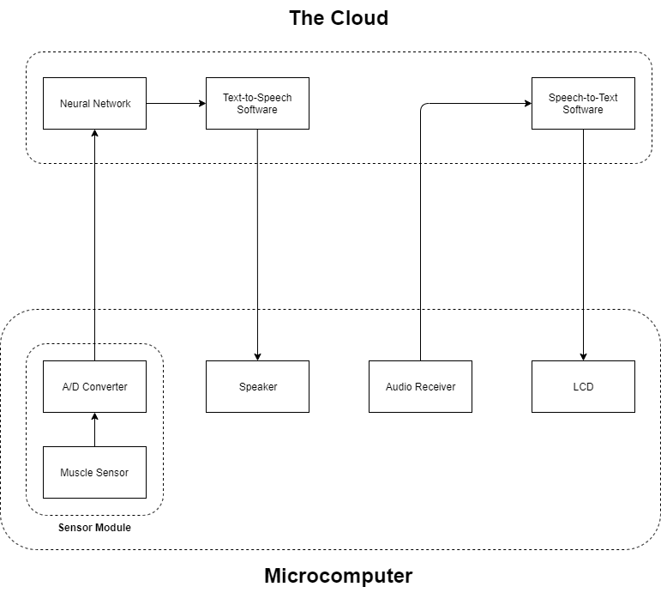

Figure 2: The system diagram of Sign AI

1. Implementation Plan

## Tasks

Task 1: Data Acquisition and Data Processing

Subtask 1.1: Interface computing devices and sensing devices.

Subtask 1.2: Write code to automatically document all sensor outputs.

Subtask 1.3: Write code to automatically format data for use in a neural network.

Task 2: Neural Network Design

Subtask 2.1: Propose a data visualization method for sensor data.

Subtask 2.2: Determine a suitable neural network architecture for the project.

Subtask 2.3: Verify the feasibility of proposed data visualization method and neural network architecture.

Task 3: Neural Network Implementation

Subtask 3.1: Create a TensorFlow model based on the results of Task 1.

Subtask 3.2: Train TensorFlow model using acquired sensor data.

Subtask 3.3: Refine TensorFlow model to optimize performance.

Task 4: Design of Gesture-to-Speech Feature

Task 5: Design of Speech-to-Text Feature

Task 6: Design of Graphical User Interface (GUI)

## Timeline/Milestones/Delivery Plan

|  |  |  |  |
| --- | --- | --- | --- |
| **Time** | **Task** | **Comments** | **Responsible Personnel** |
| Week 1-6 | Subtask 2.1, 2.2 | Data visualization method and neural network architecture. | Josheb Dayrit |
| Week 7-11 | Subtask 2.3, Task 4 | Are the proposed data visualization method and neural network architecture viable for use in project? | Josheb Dayrit |
| Week 12-15 | Subtask 1.1, 1.2, 1.3 | Collection and processing of sensor data. | Josheb Dayrit |
| Week 16-19 | Subtask 3.1, 3.2, 3.3, Task 6 | Deployment of neural network on microcomputer. | Josheb Dayrit |
| Week 20-22 | Subtask 4.3 & 4.4, Subtask 5.3 & 5.4, Task 6 | Putting all the pieces together. | Josheb Dayrit |

Table 1: Predicted timeline for tasks

1. Implementation

## Implementation of Task 1

### Implementation of Subtasks 1 and 2

#### Myo Armband

The Myo armband is the sensing device that will be used for data acquisition. It was developed by Thalmic Labs and released for consumer use on July 2014. However, it was later pulled off the shelves on October 2018, with developer Thalmic Labs citing that another project was in the works. The intent behind the Myo armband was to provide a wireless control for computers, laptops, and phones through implementation of EMG sensors and IMUs. It has also been used in academia for other purposes, such as gesture classification.

On the inside, the Myo armband contains an Invensense MPU-9150, which is a 9-axis IMU (inertial measurement unit), and 8 different EMG electrode units, which supplies 8 different EMG readings from 8 different locations in the forearm. EMG readings are pre-processed using an in-house algorithm developed by Thalmic Labs. While Thalmic Labs has made it possible to acquire raw EMG readings from Myo, their EMG algorithm still has not been disclosed to the public. In addition, Myo calculates orientation data in the form of quaternions. The 9-axis IMU processes the kinetic information necessary for these calculations. The IMU chip lies on the back of the motherboard, alongside other peripheral connections. The processor used by the Myo armband is the MK22FN1M0, which is a Freescale Kinetis Cortex M4 processor with clock speed of 120MHz. A Bluetooth module (NRF51822) can also be found close to the processor for wireless transmission and reception.

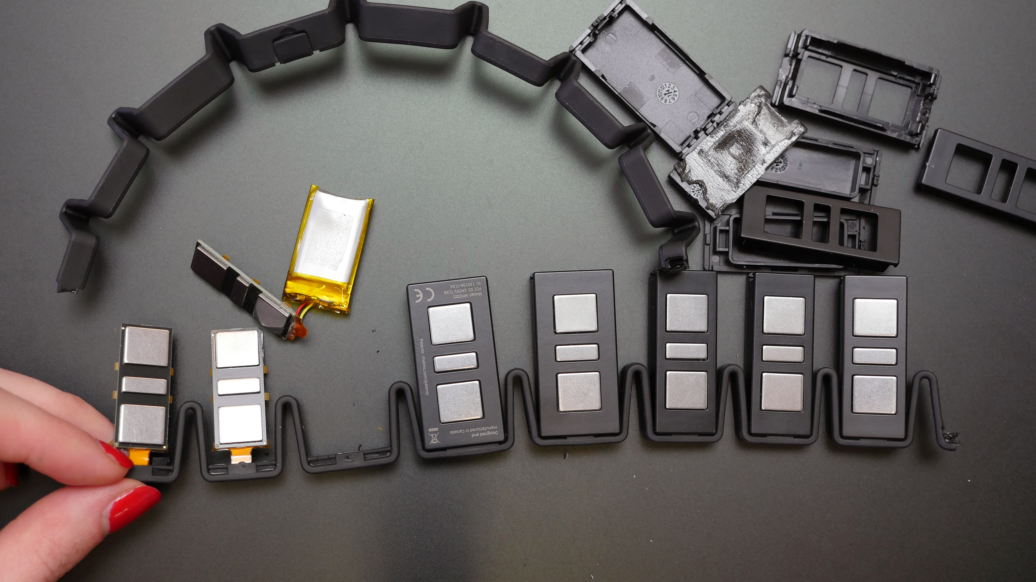

Figure 3: EMG sensor modules in Myo armband [7]

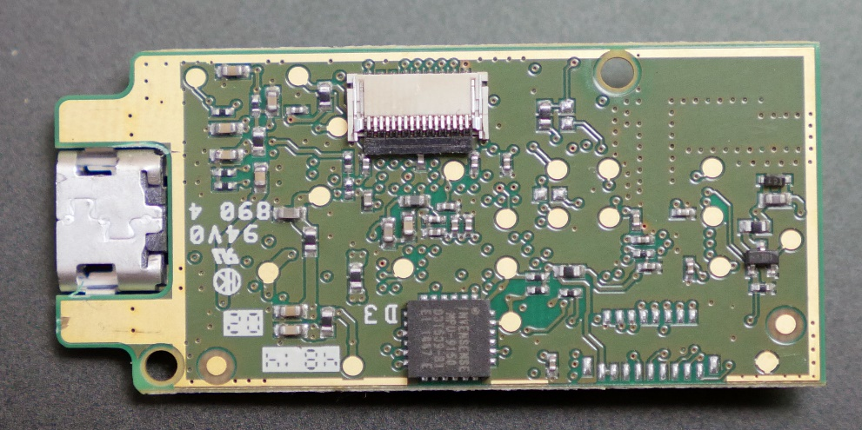

Figure 4: Invensense MPU-9150 on the back of the motherboard [7]

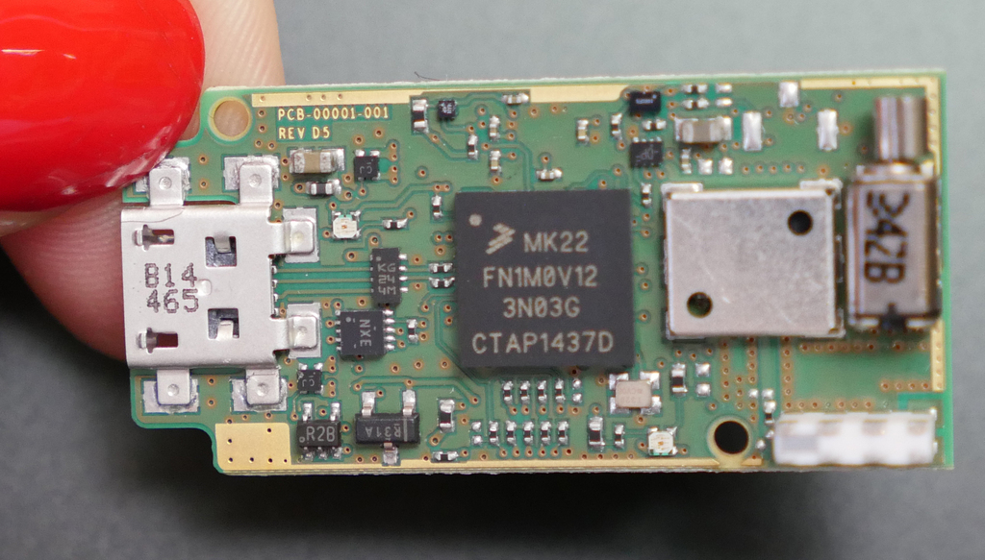

Figure 5: Processor for Myo armband [7]

The Myo armband was the sensor of choice for various reasons. First, it was readily available, provided by the Department of Engineering and Aviation Sciences. Thus, it did not cost a thing. Second, it is more than capable of performing human activity recognition on the gesture scale. In a study done by the University of Western Switzerland, the Myo armband was compared side-sby-size with more sophisticated EMG sensors. The sensors tested were the Otto Bock 13 E200, the Delsys Trigno Wireless, the Cometa miniWave, and the Myo armband from Thalmic Labs.

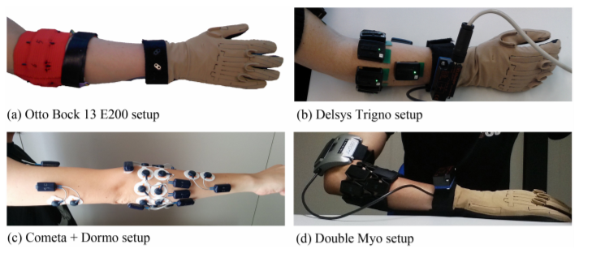

Figure 6: Setup for each sensor [8]

All neural networks regardless of architecture are data-hungry, with some being hungrier than others. The neural network requires large pools of data from which to extract features in a process appropriately named “feature extraction,” which is the process where data is “interpreted” by a neural network. In the previously-mentioned study, the Switzerland-born researchers attempted to develop a neural network for recognizing 41 hand movements. They acquired data from different EMG instruments (Otto Bock 13 E200, Delsys Trigno Wireless, Cometa miniWave, and Myo armband) to train their machine learning model. The performance of the model was evaluated for each EMG device.

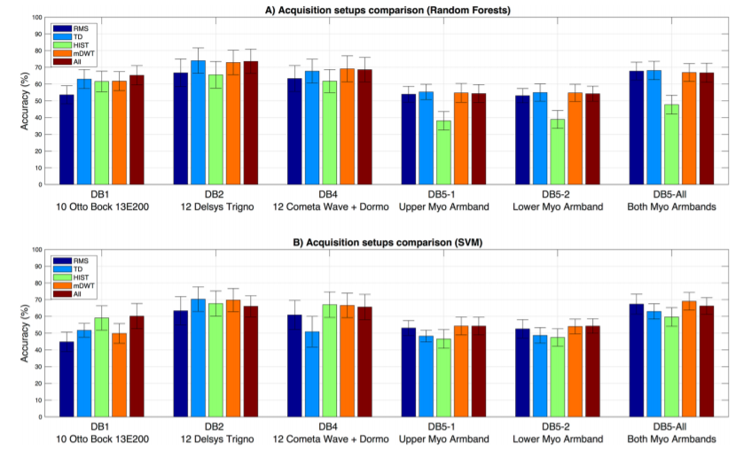

Figure 7: Accuracies of 2 models for each EMG device [8]

2 machines learning models were developed and evaluated in the Swiss study. The first model used the Random Forest classifier while the second model was an SVM (support vector machine) model. The Random Forest classifier adopts the design of a traditional decision tree. A decision tree is a series of yes-or-no choices. A machine learning model that uses a decision tree for classification seeks to divide up all available data samples into groups. Each group is associated with its own “branch” of yes-or-no choices. These “choices” are qualities which the machine learning model deems each sample group to have. The Random Forest classifier is more complex than a decision tree because it contains multiple (and, sometimes, nested) decision trees, leading to deeper understanding of data.

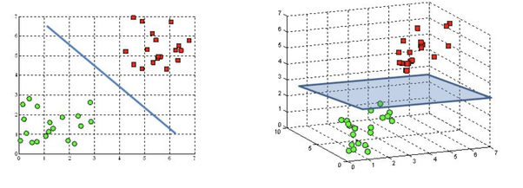

Figure 8: Hyperplanes in an SVM model [9]

Meanwhile, the SVM model is a machine learning model that relies on the concept of “extrapolation” – making inferences from prior information. Specifically, it attempts to locate data points in close proximity of each other through finding a “hyperplane.” In simple terms, the hyperplane is a boundary that delineates a clear difference between data regardless of its dimension (1D or 3D). The hyperplane is a line in one-dimensional data or a plane in three-dimensional data. It is asymptotic in nature, defining a range through which data points cannot traverse. By finding a hyperplane, an SVM model is able to pinpoint distinct qualities in different sets of data. This enables it to better classify said data.

The Swiss study concluded that, while the best accuracy was achieved through data gathered by the Delsys Trigno, all EMG devices exhibited near-equivalent results, with differences ranges from small to negligible. The Myo armbands were still able to reach accuracy values which rivaled the Delsys Trigno. Although higher accuracy was achieved by the Delsys Trigno through the Random Forest model, the performance difference between the 2 (Delsys and Myo) becomes downright non-existent with the SVM model.

The purpose of citing and giving an overview of the Swiss study was to justify usage of the Myo armband. Not only is the Myo armband the cheaper option than all other alternatives mentioned in the Swiss study, it managed to provide accurate enough EMG data to allow a machine learning model intended for classification to perform adequately. For reference, the cost of the Delsys Trigno is $35,000 while the cost of the Myo armband is a measly $300 in comparison. When attempting to fabricate a product meant for the general populace, the cost of production must be at a reasonable level. Even if one or more sensors sensor do not offer the *most* optimal performance for the job, all options must be considered and weighed against each other through different criteria. Is an increase of 1-3 percent in accuracy truly worth $30,000? The answer can depend from project to project. In the case of Sign AI, this increase in accuracy is too small to warrant its cost.

#### Data Acquisition via Bluetooth & Myo Python

There are 2 methods through which a user can view data (EMG, orientation) from the Myo. The first method is through the Myo diagnostic page located at the following link: http://diagnostics.myo.com. The second is through the Myo Python library created by Nikolas Rosenstein. All documentation related to the Myo Python library can be found on Github and PyPi. As the Myo diagnostics page cannot be web-scraped, the second option was chosen instead. Thanks to the Bluetooth module and dongle, allowing Myo to communicate data to other devices is simple and hassle-free. The remaining hurdle is writing a script to continuously acquire said data.

The Myo Python library has a class known as the Listener class, which borrows from an already-existing class, the Device Listener from the Myo SDK (Standard Development Kit). The Myo SDK was put together by Thalmic Labs and was initially written in the C language. It was later adapted to the Python language by Nikolas Rosenstein in the form of the Myo Python library. The Myo Python library acquires data from the Myo armband through the hub instance. The hub instance establishes communication with the Myo armband until the program in which it was created is terminated. After the hub instance is created, one can now access the attributes of the Listener class such “orientation,” which provides a 4-element quaternion vector calculated from the Myo armband’s IMU), and “EMG,” which provides an 8-element vector containing EMG readings from the armband’s 8 different EMG sensor modules.

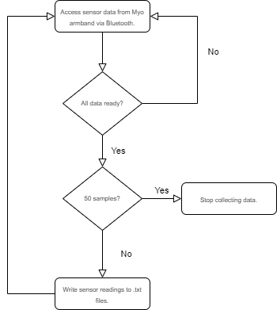

Figure 9: The data-logging algorithm

The data-logging will be implemented in Python through the specified algorithm. First, all sensor readings will be documented in their own separate text files. Readings from the first EMG sensor module will be placed in a different text file than readings from the eighth EMG sensor module. Similarly, different elements (w, x, y, and z) in the quarternion vector will be stored in their own text files as well. 50 samples of each reading will be collected, as 50 samples has proved to be sufficient in capturing the entirety of many gestures. Finally, an indicator that signifies which group of readings were taken from the same instance was implemented in the form of an integer number that is stored in a text file and continously checked by the program. Acting as a label, this number will be appended to the names of all text files created in a given instance. The number will be used to group them up when it comes time to format all the files for use in the neural network.

### Implementation of Subtask 3

Keep in mind that, for a neural network to be able to process the data given to it, said data must be in the form of an array, the dimension of which depends on the type of layers used in the network. First, the dataset of 10,000 samples was split up into two groups: one dataset (called the training dataset) will used for training the neural network while the other dataset (called the test or validation dataset) will be used to test the neural network after during each training cycle. The neural network will never see the solutions for the test dataset while the opposite is true for the training dataset.

To transform the text files containing the sensor readings, several steps must be observed. Obviously, since all text files are expressed in string or character form, they must be typecasted into their numeric counterparts. This can be easily done in Python. Additionally, since the type of data acquired from the Myo armband is time-series data, the way in which said data is packaged should reflect this as well. Fortunately, arrays are automatically suited for this, as its indices of each of the elements contained in them can substitute for time. One can assume that the indices represent the time difference between the readings. This is not a problem since, like the indices which are spaced out by a constant of 1, EMG is also sampled at a constant rate by the Myo armband. The algorithm used for formatting the sensor data is detailed by the figure in the next page.

The key to formatting the sensor data lies in stacking the readings element-wise and storing them in a master file where the neural network can process them all at once. The “numpy” library will be used to perform the stacking. Stacking the readings element-wise involves taking an array containing sensor readings from the same instances and storing said array as an element. Every interval of time, the Myo armband acquires many different readings. To represent them properly, these readings must all be stored as a single element. For example, since 50 data points were collected from the Myo armband from different sources of data, each data point must correspond with each other in accordance to their order. For example, the first data point from one source must correspond with the first datapoint taken from another source. A label is appended to the stacked array once all readings are processed. This label represents the gesture performed when the now-stacked readings were taken. All stacked arrays will be stored in a pickle file for ease of access. The benefit of storing the arrays in a pickle file is that they do not lose their format. If the arrays were to be stored in a text file, they would be turned into strings. Accessing them again would require that they be converted back into array form, which overcomplicates things. Storage in a pickle file is beneficial in that it maintains a content’s integrity and simplifies access.

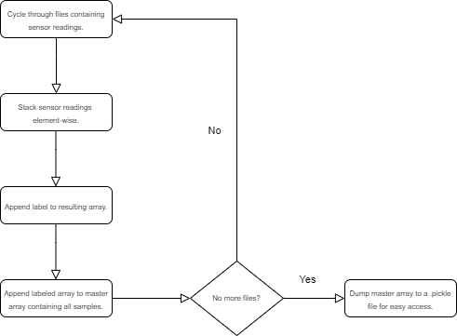

Figure 10: The data-formatting algorithm

## Implementation of Task 2

### Implementation of Subtask 1

#### Flaws of Traditional Approaches

How data is represented, in addition to the data itself, has an impact on the performance of a neural network. For projects that perform translation of ASL gestures through a neural network, data is traditionally represented as images of the ASL gestures, transformed into the array counterparts. While this method of visualizing data has produced serviceable outcomes for some ASL projects, it is not a method that is without flaws.

To start, it should be noted that static images can successfully depict certain sets of gestures. For these gestures, the final position of the hand is the distinguishing characteristic. Thus, it can be contained in a single frame. However, this is not the case for gestures where rotation or movement is a key characteristic. These gestures cannot be expressed in a single frame. The figures below show the uncanny similarities between 2 gestures. These gestures are “try” and “rock,” respectively. Although the orientations of both gestures are different, the palms are balled up for both gestures. These overlaps in final hand position will make it hard for the neural network to differentiate between gestures if given that information alone. The reason why most AI-based ASL projects do not venture beyond certain sets of gestures is because the method through which their data is expressed is narrowly focused, suitable for some circumstances but not others. This constraint prevents the neural network from doing translation work on other gestures.

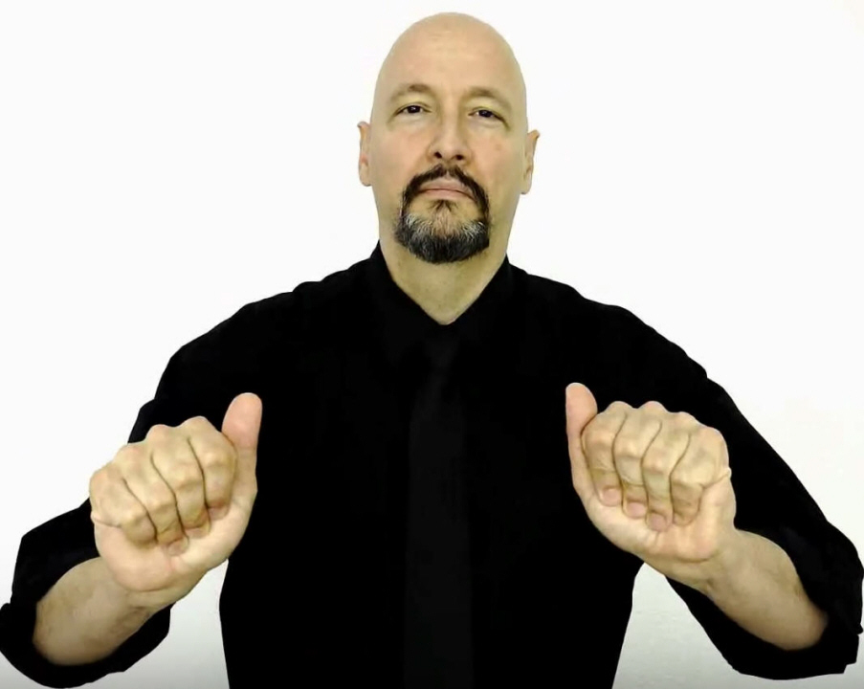

Figure 11: ASL for “try” (final hand position) [10]

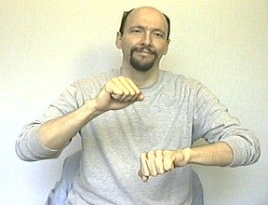

Figure 12: ASL for “rock” (final hand position) [10]

Another inherent defect of image data is the presence of image noise, which is all-too-often too hard to decouple from the desired parts of an image. In a paper on techniques for image noise reduction, Indian engineering professors Mythili and Kavitha describe 8 types of image noise in great detail: amplifier noise (gaussian noise), salt-and-pepper noise (impulse noise), shot noise, quantization noise (uniform noise), film grain, on-isotropic noise, speckle noise (multiplicative noise), and periodic noise. Although some discussion is devoted to each category of noise, discussions on impulse noise, gaussian noise, and speckle noise are particularly lengthy, as these are the most common types of image noise found in images.

The first type of noise discussed by the paper is amplifier noise (or Gaussian noise), wherein it is stated that amplifier noise is “additive” [11]. Mathematically speaking, Mythili and Kavitha disclose that, in ideal cases, amplifier noise can be quite easily modeled by a Gaussian distribution. Armed with this information, various filters have been developed and implemented by DSP (digital signal processing) researchers in order to combat it. On the fundamental level, amplifier noise is noise that adds a bias to the original red, green, and blue values of an image signal.

In another ResearchGate paper by professors from 2 European universities, Gaussian noise was applied on an image to develop techniques relating to facial recognition [12]. A progression is shown of the image as it is degraded by noise of increasing severity. Based on the differences that can be observed from the image at each stage of the “noising” process, it becomes clear how each pixel is being affected the applied noise. Comparing the original image to its noisier counterparts, one can see how pixel intensity is changed at every location in the image, with some pixels becoming grayer and others less gray. These random fluctuations in pixel intensity can be attributed to the fact that Gaussian noise is “additive,” causing parts of an image to be lighter or darker than they originally are. Such fluctuations are the “biases” mentioned in the paper by Mythili and Kavitha.

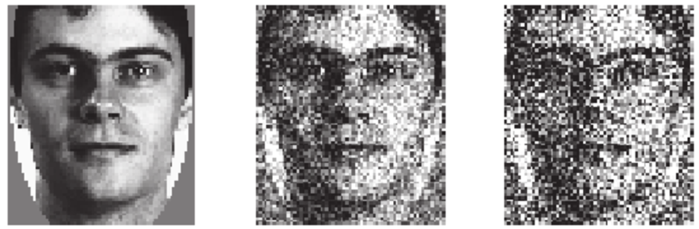

Figure 13: Gaussian noise applied to image [12]

Another commonplace noise type that is discussed in Mythili’s and Kavitha’s paper is impulse noise or salt-and-pepper noise, which is similar in some ways to amplifier or Gaussian noise. In Gaussian noise, the image is affected as a whole. However, in impulse noise, a select number of pixels are affected, which make them stand out from the rest. The primary difference between Gaussian noise and impulse noise is that impulse noise is smaller in scale and caused on the hardware side. Hardware mishaps which lead to impulse noise include non-functional analog-to-digital converters in cameras, overheating of equipment, and dust in lenses.



Figure 14: Salt-and-pepper noise applied to clear image [13]

The figure above makes the differences between impulse noise and amplifier noise rather apparent. Firstly, it is clear to see that the original image does not lose most of its integrity when the impulse noise was applied. There are fewer corrupted pixels, which means that the image is left intact apart from those pixels. By comparison, an image affected by amplifier noise essentially becomes indiscernible.

The final noise type covered in detail by Mythili and Kavitha is speckle noise, which, unlike Gaussian noise, is multiplicative rather than additive. In particular, satellite and radar technologies are said to be more acutely affected by speckle noise, as it is a direct result of interference from the surrounding area. Image-capturing hardware ranging from mundane devices like cameras to more sophisticated contraptions such as the Synthetic Aperture Radar rely on the concept of backscattering. In the case of the Synthetic Aperture Radar, an image is captured through a mixture of steps involving the radar itself and the specimen. First, the radar illuminates the specimen with a light of its own. Then, sensors on the radar pick up the light that is reflected back to it. This back-and-forth interaction between the radar and the specimen is known as backscattering. Once the reflection is received by the radar, it is processed digitally; based on this reflection, the radar reconstructs its version of the specimen.

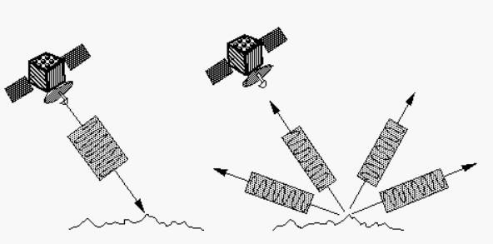

Figure 15: An imaging radar at work [14]

In the concept of backscattering, the parameter that matters most is the energy that is reflected by the specimen. An article by NASA on radar technology reveals that the energy of the echoed photon signal can determine the brightness of an image that is produced. Specifically, it states that “bright features mean that a large fraction of the radar energy was reflected back to the radar, while dark features imply that very little energy was reflected” [14]. In addition to the energy of the reflected signal, there are also environmental and material-specific factors that can influence the quality of an image. For example, in radar images, specimens which contain more water generally appear brighter than their dry counterparts. This is because water has an effect on an object’s electrical properties. When water molecules comes into contact with an object, they cohere with other molecules and form a barrier on top of the skin. The resistance of the skin is reduced because it is connected in parallel to the layer of water. Variance in a specimen’s resistance can also dictate if an object appears brighter or darker in a radar image.

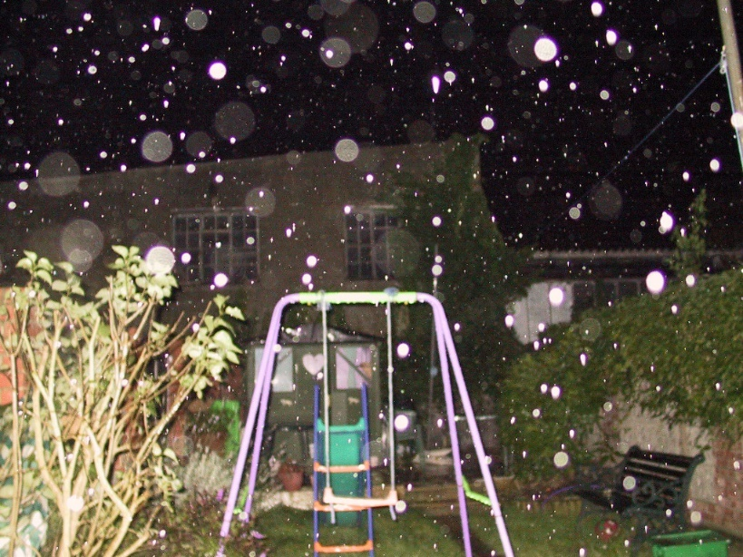

Figure 16: Water droplets captured in an image

Radars and cameras are similar in that backscattering can affect the quality of images that both produce. For cameras, the negative impacts of backscattering can be particularly observed in images where small obstructions such as droplets of water appear as clear or white imperfections. Whenever there are small particles littered about in the frame of a camera, the chance of producing an image with undesirable affectations increases drastically. In addition to water droplets, fine substances like dust or sand can also produce similar affectations in an image. The factor that influences these affectations is distance. According to the Inverse-Square Law, light is reflected more strongly if it is closer to its source. By virtue of being closer to the camera lens, the water droplets in the figure above appear brighter and more prominent than the rest of the image.

Image noise is the prevailing reason why data from image-capturing devices proves to be unreliable for use in a neural network. There are simply too many factors – some controllable, while others not – that can affect image data from image-capturing devices. It will take a lot of work just to pre-process the data and isolate the desired parts. Even if a researcher decides to train the neural network to be able to recognize noise from the gestures, it will take a large pool of data to tackle such a complicated problem. The complication is due in large part by the various types of noise that can exist in a single image. To be able to recognize them all, a neural network would need an abundant number of samples. Otherwise, the alternative would be to develop numerous robust filters capable of suppressing noise to an acceptable but preferably ideal level.

#### Why Collect EMG and Quaternions?

The Myo armband will be used to acquire information for the classification neural network. Although the armband is meant to be employed as a wireless control for computing devices such as laptops and personal computers (PC), in the development of an ASL translation tool, it will fulfill a different purpose. The Myo armband is equipped with a variety of sensors meant for detecting gestures performed by a user. It has 8 EMG sensor modules to measure muscle activation and a 9-axis inertial measurement unit to estimate its orientation in space through calculating quaternions. These sensors will provide 2 crucial pieces of information to the neural network: the location of the muscles that are activated for each gesture and the motion of a person when he or she performs a gesture.

### Implementation of Subtask 2

#### The ConvNet (Convolutional Neural Network)

The convolutional neural network (or ConvNet, for short) is a neural network architecture whose specialty lies in the field of image processing. Many ASL projects have used the ConvNet for the translation of ASL gestures, often achieving successful results. The typical approach of such projects is to use images of the ASL language as training material for the neural network.

When the human eye sees an image of a cat and a dog, it is able to pick out which image is depicting the cat and which the dog. The brain receives stimulus from sensing organs and interprets said stimulus through a series of chemical reactions. Learned patterns and prior knowledge enable the brain to interpret new information. Unsurprisingly, something similar is done in machine learning models. The neural network is, after all, just a mathematical abstraction of the brain.

The early origins of the ConvNet can be traced to an experiment conducted by a pair of scientists Hubel and Wiesel in 1962. The Hubel and Wiesel experiment involved observations of the visual cortex. Using cats as a test group, Hubel and Wiesel determined that the neural response of a stimulus can vary depending on how it is presented. When the pair shined a light over an empty region of paper, the cats did not respond, and their neurons registered little to no activity [15]. However, when the light was instead shined on a cluster of vertical lines or horizontal lines, the cats displayed significant brain activity [15]. Specific sets of neurons, organized in rows and columns, were activated each time the light was shined on the lines. This study of the visual cortex served as an inspiration for the design of the ConvNet.

The selling point of the ConvNet is the convolutional layer, which is a layer that takes 3D arrays as inputs. When a convolutional layer is defined in Tensorflow or Keras, 3 parameters must be provided: input size, the number of nodes, and the filter size. As an analog, one can think of the convolutional layer as the visual cortex of a ConvNet. The filter is an important aspect of the convolutional layer because it is multiplied element-wise to the input array. It is an array itself, which is composed of parameters called “weights” – numbers that influence and decide the outputs of a layer. The size of a filter is specified by the user, and it cycles through the input array piece-wise like a magnifying glass. The dot product is taken of the filter array and a segment of the input array (called the “receptive field”), and the result is put into another array called the “feature map” – the ConvNet’s interpretation of an image, expressed in numerical form (a one-dimensional array). Based on the feature map, the ConvNet is able to pick up on characteristics in an image, like curves or corners.

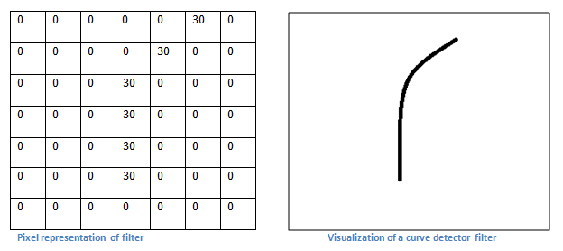

Figure 17: A filter tuned for detecting curves in an image [16]

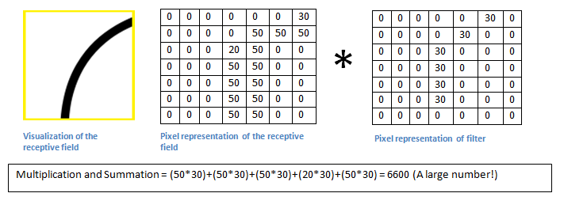

Figure 18: Dot product of the receptive field and filter [16]

In the two figures above, an example is given of the mathematics involved in calculating an element of the feature map from the filters and receptive fields. The dot product of the two arrays are taken, which results in an element for the feature map. The produced element is related to the filter because it determines if a desired attribute (i.e. a curve or corner) has been detected in the receptive field. If the number is high, then it is probable that the receptive field contains the desired attribute. Through the feature map, the ConvNet is able to extract characteristics from the input array, which it can use for purposes of classification or prediction.

In an ASL project conducted by a computer scientist (Vivek Bheda) and a linguist (Dianna Radpour) from the University of New York, the pair attempted to use the ConvNet for classifying the most basic ASL hand signs, which are the letter and number hand signs. In total, 36 hand signs were processed by the ConvNet, consisting of letters from A to Z and numbers from 0 to 10 [17]. Supervised learning is the name of the game for dozens of machine-learning models, including the model designed by Bheda and Radpour. It is a kind of learning where the inputs and outputs are pre-established. In supervised learning, the task of the neural network is to engineer a way of mapping inputs to the correct outputs.

In terms of design, the model developed by the team of Bheda and Radpour adheres to the conventional structure of a ConvNet, which is a conglomeration of convolutional layers, dense (or fully connected) layers, and other supplementary layers used for minimizing computational load. The layer that differentiates the ConvNet from neural network architectures similar to it is the convolutional layer, a special layer that processes an image piecewise rather than as a whole. Using the standard ConvNet architecture, Bheda and Radpour were able to achieve accuracies ranging from 80 to 90 percent, which meant that their ConvNet only failed to distinguish a gesture 10 to 20 percent of the time, depending on the gesture.

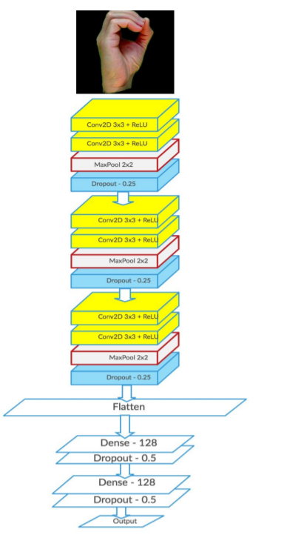

Figure 19: Design of Bheda and Radpour’s ConvNet [17]

#### LSTM (Long-Short Term Memory) Model

The LSTM model falls under the umbrella of the recurrent neural network (RNN). For context, the RNN is a type of neural network that excels in processing sequences of data. It is able to do this through transmitting prior information to later parts of a neural network. Most neural networks are feed-forward networks, meaning that information flows in a single direction. Every layer in a feed-forward neural network produces outputs that other layers are not able to access. The other layers are not told how these outputs are produced. This is where the RNN begins to diverge from the traditional feed-forward neural network. The RNN interconnects outputs of layers by passing said outputs from one layer to the next through a loop. Prior information is known as the “hidden state” in the realm of deep learning. The hidden state relays more than just the outputs of a previous layer. It also describes how previous outputs have changed over time while in previous layers. RNNs have layers with feedback loops, and this is where the hidden state is passed on and updated. In an RNN, the hidden state of a previous layer can affect the outputs of the following layers because it is processed in conjunction with the inputs of the following layers.

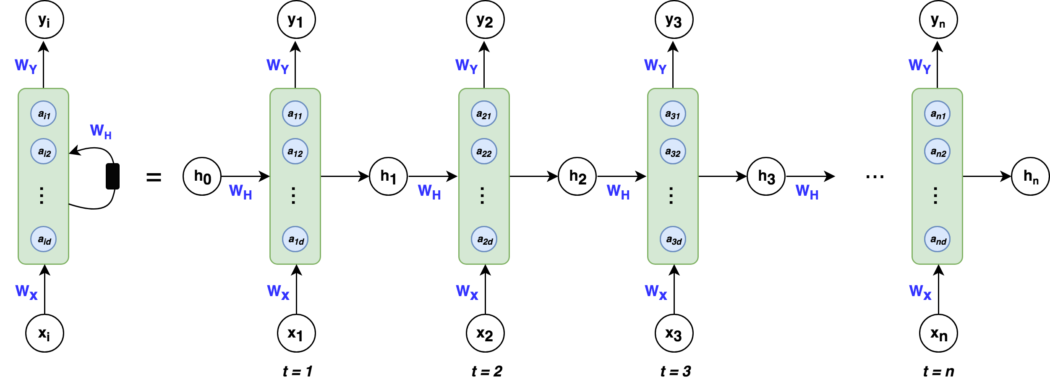

Figure 20: A simple RNN layer [18]

The specialty of the LSTM model is memorizing long-term dependencies or patterns in data. There are mechanisms within an LSTM layer that allows it to keep track of dependencies. In an LSTM layer, two elements are responsible for memorization: the cell state and the gates. For reference, the terms “cell state” and “hidden state” can be used interchangeably. The cell state is an additional output produced by an LSTM layer. It is where changes in the input are documented. The cell state and gates go hand-in-hand in that the gates are responsible for updating the cell state. In short, the “gates” are activation functions which have a binary range, meaning their outputs lie between 0 and 1. An output of 0 indicates that the input underwent no change. Therefore, the cell state is not updated. The opposite is true if the gates produce a result of 1.

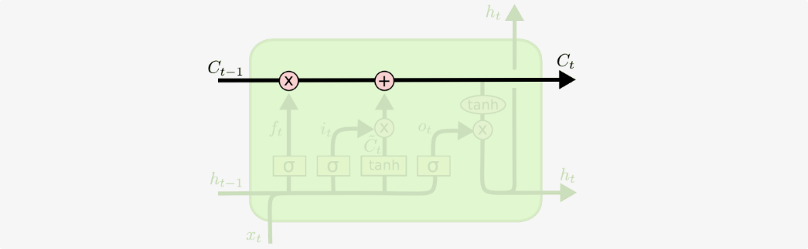

Figure 21: The cell state, highlighted in a diagram of an LSTM layer [19]



Figure 22: The “gates,” denoted by a lowercase sigma (σ) [19]

What separates the LSTM model from a run-of-the-mill RNN is the ability to update the cell state by adding *and* removing information through the gates. A single LSTM layer contains 3 gates. The first gate – a sigmoid activation function – is knows as the “forget” gate. True to its name, it removes information from the cell state once it receives the “okay” to do so. This “okay” comes in the form of a “0” output. If the state of the “forget” gate is one, the cell state will remain unmodified. For understanding, an activation function is called an “activation” function because its job is to “activate” values in a layer. This “activation” comes in the form of analyzing endless streams of values and determining through a binary decision which values should be kept. Information is removed from the cell state through a bitwise AND operation between it and the “forget” gate.

Following the “forget” gate is the “update” gate. True to its name, it is responsible for adding information to the cell state. Similar to the “forget” gate, the “update” uses the bitwise AND operation to change the contents in the cell state. The one difference is the presence of the hyperbolic tangent, which scales the added content to a comfortable range that is easier to manage by the neural network. The hyperbolic tangent was not necessary for the “forget” gate, as it was not adding information to the cell state.

The final gate (rightmost) in an LSTM layer is the “output” gate. To put it simply, the “output” gate determines the output of an LSTM layer. Two activation function are used in this gate. The first activation function is the sigmoid activation function, which is denoted by a lowercase sigma. The second activation is the hyperbolic tangent, which works side-by-side with the first activation function. The sigmoid layer will filter the cell state and keep the relevant values. Meanwhile, the hyperbolic function will be used to scale the cell state between a range of -1 and 1. Having a localized range makes computation easier for the neural network.

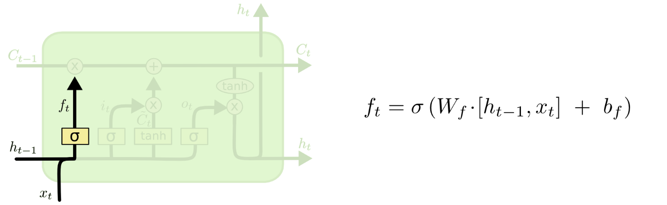

Figure 23: “Forget” gate, highlighted in a diagram of an LSTM layer [19]

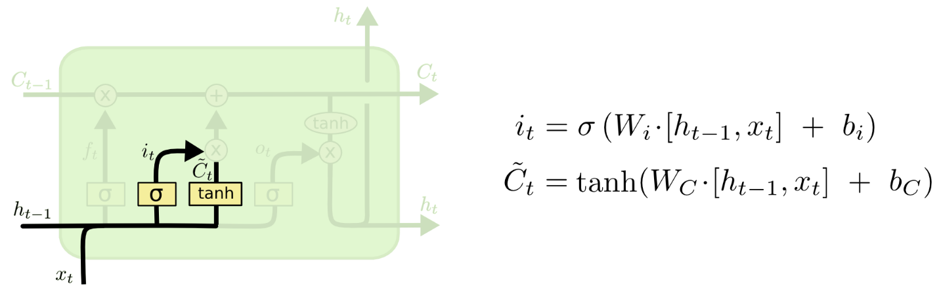

Figure 24: “Update” gate, highlighted in a diagram of an LSTM layer [19]

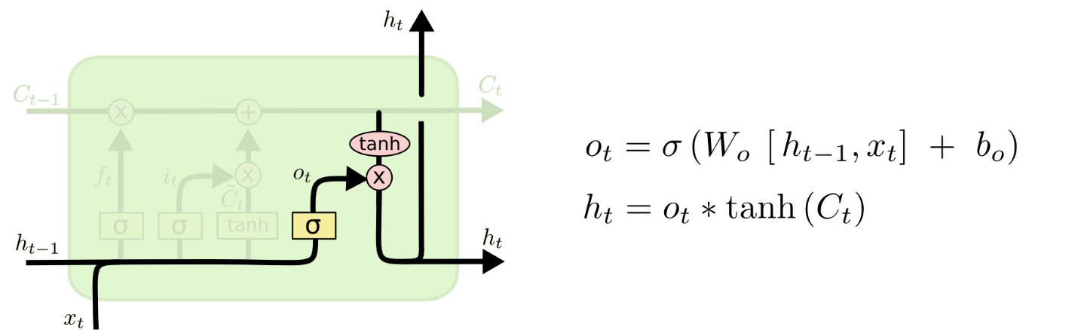

Figure 25: “Output” gate, highlighted in a diagram of an LSTM layer [19]

### Implementation of Subtask 3

Is the LSTM model suitable for gesture classification? The answer is a resounding “yes.” When one is considering the architecture of a neural network, one must also consider the data that will be processed by said architecture. There is a correspondence between the architecture and the processed data. The processed data will relay important information to the network, while the network interprets relayed data and outputs a value that represents it. The factor that determines if a network is suitable for solving a problem is its ability to interpret the input data. What information is hidden in the data? Are there patterns or dependencies? What is the size of the data? Does the data vary with time? Is the proposed network capable of understanding subtext in the data? The following questions bring up some important considerations. In all considerations, the bottom line is that the neural network must be able to “read between the lines” and decipher desired chunks of information.

What makes the LSTM model suitable for gesture classification? The answer lies in its ability to memorize long-term patterns and dependencies. Recall that the LSTM model contains layers which update themselves based on the changes that the input data undergoes in the network. These “updates” are representative of the patterns and dependencies that the network has extracted after processing the input data. The input data will come in the form of readings from EMG sensors and a 9-axis IMU. These readings vary with time and correspond to a gesture. The job of the neural network is to determine the performed ASL gesture based on the aforementioned readings. To be successful, it will need to keep track of changes in the sensor readings. In other words, it will need to memorize patterns and dependencies. This need is fully met by the LSTM model, due in large part to its design and intended function.

## Implementation of Task 3

### Implementation of Subtasks 1 and 2

#### Keras API for Tensorflow

The realm of deep learning has been gaining traction over the years. For one, the result of decades of progress has culminated into the development of sophisticated AI like Sophia, a robot AI which is capable of holding complex conversations and stringing together human-like sentences. Perhaps the most profound effect of the increasing prominence of AI lies not in the new technologies, but in the development of tools which simplify the process of creating an AI. TensorFlow is one such tool. TensorFlow is an open-source Python library containing pre-programmed functions meant for designing, testing, and exporting neural networks. For many beginner AI developers, TensorFlow is usually accompanied with the Keras API, which simplifies the AI development process even further. The Keras API allows user to define layers in a neural network sequentially using the “Sequential” and “add” functions. In addition, the Keras API wraps many lines of pure TensorFlow code into singular, compact lines for ease of use. However, some customizability is sacrificed as a result. Due to the fact that both Keras and TensorFlow are user-friendly, well-supported, and well-maintained, they will be used to develop a gesture recognition neural network.

#### Training a Model in TensorFlow Using the Keras API

Training a model using the Keras API for TensorFlow is quite simple. First, the “compile” function must be called. This step assumes the neural network architecture has already been specified. The “compile” function requires 3 mandatory arguments: optimizer, loss, and metrics. The optimizer and loss arguments can vary depending on the neural network architecture, but the “metrics” argument is traditionally “accuracy.” This will be the criteria by which the model is evaluated during training and testing. Following the “compile” function, the “fit” function is called next. The “fit” is where the model is trained and where the test and train datasets are loaded. It has many customizable arguments. However, the mandatory arguments are x, y, and epochs. All other arguments will assume their default settings. “X” represents the dataset to be used for training while “y” represents the labels or solutions to the specified dataset. The number of epochs determines the number of training cycles the model will be trained for.

### Implementation of Subtask 3

#### Stacked LSTM Layers

In the paper “How to Construct Deep Recurrent Neural Network” written by Bengio et al., much discussion was devoted to depth of RNNs and RNN variants like the LSTM (Long Short Term Memory) RNN. Bengio et al. state that, for feed-forward neural network, a deeper model often leads to a “more expressive model,” meaning that the model is able to understand data at a higher level [20]. They suggest that the same proposition could lead the same outcomes for RNNs. Their discussion referenced another paper written by Herman and Schrauwen. This paper is essential in understanding the real impact of stacking recurrent layers.

In the Herman and Schrauwen paper (titled “Training and Analyzing Deep Recurrent Neural Networks”), some background was explored regarding the default depth of a single layer in an RNN: “when folded out in time, it [RNN] can be considered as a DNN with indefinitely many layers” [21]. A DNN is an abbreviation used to describe deep neural networks. Herman and Schrauwen claim that an RNN is, in their opinion, a DNN that possesses infinite layers. The “infinite layers” commentary refers to the basic structure of an RNN. A layer of an RNN has an internal memory that enables it to process data sequences. This internal memory is known as the “cell state.” Variants of the RNN like the LSTM RNN also have cell states. The cell state is updated through feedback loops in an RNN that propagates new and old information. If the input data is infinitely long, then data is infinitely propagated through a layer, making the RNN infinitely deep. Herman and Schrauder were alluding to the persistent nature of the RNN by saying it is “infinitely deep.”

Later in the paper, Herman and Schrauder delve into the design of an RNN, particularly the logic behind it: “For RNNs, the primary function of the layers is to introduce memory, not hierarchical processing.” Hierarchical processing in neural networks is the idea that new knowledge is extracted at each layer. Herman and Schrauder believe that hierarchical processing is not the aim of an RNN. They also believe that shallow hierarchical processing can limit an RNN’s performance, even listing several performance-affecting limitations:

“One potential weakness of a common RNN is that we may need complex, hierarchical processing of the *current* network input, but this information only passes through one layer of processing before going to the output… Secondly, we may need to process the time series at several time scales. Common RNNs do not explicitly support multiple time scales, and any temporal hierarchy that is present in the input signal needs to be embedded implicitly in the network dynamics” [21].

Herman and Schrauder are making the following assertions: that the RNN does not excel in hierarchical processing, which can affect its understanding of the input, and that the RNN is not by default capable of analyzing data piece-wise with respect to time. To address these concerns, the following proposition was made and later verified:

“The architecture we study in this paper is essentially a common DNN (a multilayer perceptron) with temporal feedback loops in each layer, which we call a deep recurrent neural network (DRNN). Each network update, new information travels up the hierarchy, and temporal context is added in each layer (see Figure 1). This basically combines the concept of DNNs with RNNs. Each layer in the hierarchy is a recurrent neural network, and each subsequent layer receives the hidden state of the previous layer as input time series. As we will show, stacking RNNs automatically creates different time scales at different levels, and therefore a temporal hierarchy” [21].

Essentially, Herman and Schrauder are proposing a fusion of the DNN and RNN. Dense layers will be used to increase hierarchical processing, while RNNs will be stacked for the purpose of giving temporal context to the input data at different instances of time.

Due to the benefits of increased hierarchical processing and temporal context, our paper will be adopting Herman and Schrauder’s architecture. To recap, the Myo armband will be providing multiple sensor readings to the neural network, some different types. Specifically, EMG and orientation data will be used by the network to classify ASL gestures. If the network lacks hierarchical processing, it will not be able to understand the spatial context between the readings. Here, “spatial context” refers to the knowledge of which sensor produces which reading. In addition, without the memory of an RNN layer, temporal context will be lost. This means that the network will be unable to recognized time-based patterns. Herman and Schrauder’s architecture combines the hierarchical processing of DNNs and the temporal context from RNNs to process data from multiple perspectives.

#### Dropout

By all accounts, a stacked LSTM model is a large neural network. This can be problematic if the dataset used for training is small. Having a large neural network but small dataset is one indicator of overfitting. The Sign AI project has 100 labels, with each label corresponding to an ASL gesture. Each label contains 100 samples, resulting in 10,000 overall samples. The label-to-sample ratio is 1:100. While there is no standard that defines a “small” or “large” dataset, it is preferred to have more samples. More samples suggest that the dataset is diversified, covering data containing differentiations variations with which to train the network. The dropout layer is one age-old defense against overfitting. Its merits are discussed in depth in “Dropout: A Simple Way to Prevent Neural Networks from Overfitting” written by Hinton et al.

Deep neural networks are beneficial in that they are able to learn complicated relationships. This is corroborated by Hinton et al., who state that having multiple layers help the network recognize underlying connections between inputs and outputs. In addition to its architecture, a neural network also relies on training data, which it dissects for hidden information. Ideal circumstances mean that training data is abundance. However, this is not always the case. A limited dataset can cause a neural network to overfit without proper regularization, which is a means of increasing a network’s ability to “generalize.” If a network is capable of “generalizing,” then it is able to handle data that it has not been trained with. A network not capable of generalizing is considered to be “overfit.” Training a neural network involves micro-managing weights and biases, both of which are parameters that dictate the network’s response to inputs. At every epoch or training cycle, weights and biases are constantly overwritten in an attempt to find the most ideal values. There are many reasons behind an overfit model. One obvious culprit is the number of epochs. If the neural network is exposed to the training data for a long time, it will start to develop weights which respond well to the training data but no other data than that. In other words, the neural network will perform poorly when processing data it has not been trained with.

An often-used form of regularization, the dropout method is a method which randomly disables nodes in a layer (or layers) of a neural network. In the Keras API, one can specify the percentage of nodes to be disabled by passing it as an argument to the dropout layer. As discussed in Hinton et al.’s paper, there is a biological basis behind the dropout method, one rooted in the topic of genetics and the passing of genes:

“Since a gene cannot rely on a large set of partners to be present at all times, it must learn to do something useful on its own or in collaboration with a small number of other genes. The role of sexual reproduction is not just to allow useful new genes to spread throughout the population, but also to facilitate this process by reducing complex co-adaptations that would reduce the chance of a new gene improving the fitness of an individual” [22].

In the following excerpt of Hinton et al.’s paper, the role of dropout in a neural network is explained through the concept of natural selection. The key words are “reduction” and “co-adaptations.” In biology, evolution forces individuals to develop new genes. These genes are supposed to help humans develop advantageous characteristics. The end goal is to develop new *and* advantageous genes. This is done through minimizing interplay between genes, known as biological co-adaptations. Co-adaptation is a phenomenon in which a person’s characteristics are determined by gene pair. Each gene relies on its counterpart to remain functional. These dependencies between genes are not desirable as they create multiple points of failure. Co-adaptation also exist in neural networks in the form of dependencies between layers. Co-adaptations between layers in a neural network can be minimized through dropout. Each layer feeds information into future layers, which can create unwanted or unintended dependencies between layers and cause the neural network to overfit. One way to reduce these dependencies is by preventing small chunks of information from reaching future layers, which the dropout method accomplishes through shutting down nodes. The logic behind the dropout layer is to force layers to be more self-reliant and infer the missing information themselves.

#### Batch Normalization

In the context of neural networks, batch normalization is a method of standardizing inputs. Batch normalization addresses several problems related to the performance and training of a neural network. A paper written by Sergey Ioffe and Christian Szegedy (titled “Batch Normalization: Accelerating Deep Network Training by Reducing Internal Covariate Shift”) discusses the merits of batch normalization in explicit detail. The internal covariate shift is touted by Ioffe and Szegedy as something that is negative, having an adverse effect on a neural network. Ioffe and Szegedy justify their claim by bringing up the distribution of inputs in layers:

“The change in the distributions of layers’ inputs presents a problem because the layers need to continuously adapt to the new distribution. When the input distribution to a learning system changes, it is said to experience covariate shift” [23].

In the following excerpt, Ioffe and Szegedy define internal covariate shift as the inevitable changes in the flow of information from layer to layer. If a neural network is series of layers, then a layer is a series of nodes, which are receptacles for the input. Where information goes node-wise is random. This randomness can create problems if the input has a wide range. As stated before, the goal of training is to tune the weights and biases of a neural network. Weights and biases interact with nodes in that they determine the significance of the received input. If a node is associated with a high-magnitude weight (in other words, it is strongly connected to the output of another node), this means that the specific piece of the input going through it will greatly influence its output.

Before one can understand the impact of batch normalization on a neural network, one must first understand how its weights are updated. In a neural network, data flows forwards and backwards. The backwards flow of data is called “backpropagation.” The job of a neural network is to map inputs to appropriate outputs. During training, outputs is pre-determined. The important parameter is the network’s prediction. Weights are updated depending on the exactness of the prediction. How is this “exactness” quantified? The answer lies in the concept of error. Error needs to be calculated for every node in a network and sent back for processing. This “sending back” is backpropagation at work. It is an algorithm which calculates the gradient or partial derivative of the cost function with respect to the network’s weights. For reference, the term “cost” is synonymous with “error” and “loss.”

Several intricacies still need to be addressed before the effect of batch normalization can be fully explained. First, what is the cost function? Second, how is the cost function calculated? The cost function is a function which describes the range of performance of a neural network based on the number of training samples, number of layers, and the output of every node. The desire of every network is to reach the global minimum of a loss function, as this would mean that the network is performing at its best. Now, the question needs to be asked: how is backpropagation used to update weights? To reiterate, error is the parameter that flows backwards through the network. Every node has an error value associated with it, which will used to determine if the network is navigating the cost function towards the global minimum, the ideal case. New costs are compared with old costs, and, if the new costs are lesser, then the neural network updates itself by overwriting previous weights with the weights determined in the most recent epoch or training cycle.

How does batch normalization benefit the neural network? Batch normalization is, in essence, a rescaling of the weights to a localized range. Ioffe and Szegedy mention in their paper a phenomenon called “internal covariance shift,” explaining that the purpose of batch normalization is to minimize the influence of such a shift. First, what is “internal covariance shift”? Ioffe and Szegedy explain it as the variations in the outputs of each node in a layer, which are received as inputs by other nodes from another layer. These variations are thought to worsen as parameters such as weights and biases are updated for every layer in a network. The particular term Ioffe and Szegedy use for the outputs of the nodes is “hidden unit values.” In addition, rather than using the word “variation,” the more accurate word would be “distribution.” As weights and biases of previous layer change, so do the distribution of inputs that enter the subsequent layers in a neural network. Changes in input distributions can cause the network’s performance to shift wildly, as the network has to continuously accommodate for new input distributions. With Batch Normalization, the stability of input distributions are increased as all hidden unit values in the affected layers are made to have zero mean and unit variance. To be more specific, the hidden unit values are forced to conform to a standard normal distribution.

There have been papers written that conflict with Ioffe and Szegedy’s ideas, however. One paper written by MIT PhD students argue with proof that the purpose of batch normalization is not to reduce the internal covariance shift of a neural network in any way. In fact, an experiment was conducted in the paper that proves this is not the case. One of the primary objectives of the paper was to verify the connection between reduction in the ICS (abbreviation for “internal covariate shift”) and batch normalization. The experiment conducted by the paper involved training networks where noise is injected to disturb input distributions:

“We propose the following experiment. We train networks with random noise injected after BatchNorm layers. Specifically, we perturb each activation for each sample in the batch using i.i.d. noise sampled from a non-zero mean and non-unit variance distribution. We emphasize that this noise distribution changes at each time step (see Appendix A for implementation details)” [24].

The reason for injecting noise is rather clear from the authors’ perspective: to create the effect of skewed input distributions. With the implementation of batch normalization layers in their network, the authors (Ilyas et al.) sought to prove or disprove the supposed “power” of batch normalization to fix the uneven distributions and thereby reduce the ICS (which is expected to increase the network’s performance as a result). Ilyas et al. discovered that, while the normalized network performed better than the non-normalized networks, it was not due to reduction in the ICS that this was so. In fact, the batch normalization layers did little in addressing input distributions:

“Observe that the performance difference between models with BatchNorm layers, and ‘noisy’ BatchNorm layers is almost non-existent. Also, both these networks perform much better than standard networks. Moreover, the ‘noisy’ BatchNorm network has qualitatively less stable distributions than even the standard, non-BatchNorm network, yet it still performs better in terms of training” [24].

Ilyas et al. were thorough in their experiment, comparing the performance of a normalized network with noise injected against a normalized network without noise. Despite having “less stable (input) distribution,” the network with the injected noise displayed better performance than its noiseless counterpart. Clearly, the connection between improved performance and reduction in the ICS is not substantiated in practice. Ilyas et al. also proposed their own ideas on the exact effect of batch normalization; an additional experiment was also conducted to prove or disprove it. According to Ilyas et al., the merit of batch normalization lies in a rather fundamental concept:

“Instead, we identify a key effect that BatchNorm has on the training process: it reparametrizes the underlying optimization problem to make it more stable (in the sense of loss Lipschitzness) and smooth (in the sense of ‘effective’ β-smoothness of the loss). This implies that the gradients used in training are more predictive and well-behaved, which enables faster and more effective optimization” [24].

Ilyas et al. state that the reason why batch normalization is so effective is because of its reparameterization of the “underlying optimization problem” being solved by the neural network during training. One might ask: what is the optimization problem that the neural network is solving? The answer lies in the gradient of the cost function. Recall that the goal of training a neural network is to reduce error in predictions, which means navigating the cost function towards its global minima. How does the neural network determine that the error has been reduced? It does so by looking at the gradient, which is an expression for the rate of change of *something*. After all, a gradient is simply a partial derivative. The gradient tells the neural network which direction it is traveling the cost function. Since Ilyas et al. have stated that batch normalization makes the gradient “more predictive and well-behaved,” the network will display more stable performance during training as it knows with more certainty where it is going. “Well-behaved” in this case is a reflection of the gradient’s “Lipschitzness” as mentioned by Ilyas et al. The mathematical concept of Lipschitzness deals with gauging a function’s continuity, the criteria used by Ilyas et al. to measure “smoothness.” More continuous functions tend to have less regions where the change from one value to another value is too significant and abrupt. A continuous function *looks* more connected and is therefore more “smooth.” In short, smoother gradients are beneficial because of their continuity.

#### Finalized Neural Network

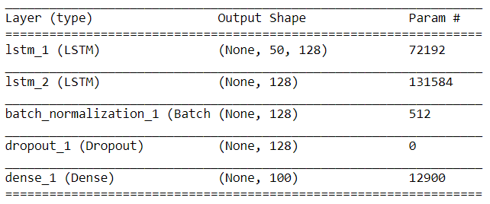

Figure 26: The architecture of the finalized neural network

#### Model Performance

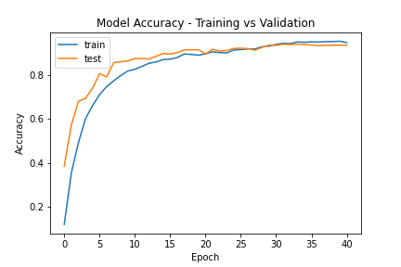

Figure 27: Comparing the accuracy of the neural network in 2 datasets (train and test)

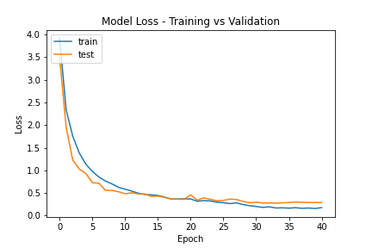

Figure 28: Comparing the accuracy of the neural network in 2 datasets (train and test)

#### Discussion on Model Performance

When evaluating the performance of a neural network, one must examine 2 parameters: loss and accuracy. The loss of a neural network is a number indicative of the network’s tendency to make prediction mistakes, while its accuracy describes in percentage form its success in making predictions. There is a relationship between loss and accuracy that can tip off signs of overfitting. Recall that there are 2 datasets that the neural network must be able to solve: the training dataset and the test or validation dataset. The neural network sees the solutions to the training dataset, so it is able to compare its prediction to said solutions. However, the solutions to the validation dataset are not visible to the neural network, which means that the loss and accuracy of the validation dataset are more telling in gauging the network’s true performance. For reference, the training dataset is 8000 samples large while the validation set is 2000 samples large. When there are significant differences between the training outcomes and the validation outcomes, this should raise flags that the neural network is overfitting.

Thusly, several methods of regularization were used to prevent the neural network from overfitting. Among these methods, dropout and weight constraints were used. Dropout regularization was employed through adding dropout layers in the neural network, while weights constraints required the use of the “max norm” function from the Keras library. As discussed before, the benefit of dropout lies in the ridding of dependencies between layers and forcing layers to “think for themselves.” This is done through disabling nodes in a layer, ensuring that not all information will flow to the subsequent layers. On the other hand, max norm regularization involves ensuring that weights stay within a specified range. Keras checks each weight and rescales the weights which exceed the constraint put on them.

Another factor which affects the weights of the neural network is the learning rate. The responsibility of the learning rate is to dictate the factor by which weights change per batch of data that the network is trained with. In order to maximize performance, the learning rate was artificially manipulated through the use of the Keras “reduce LR on plateau” function. The “reduce LR on plateau” function takes in several mandatory arguments: monitor, factor, min LR, and patience. The “monitor” argument describes the metric by which one is evaluating the neural network (loss, accuracy, etc.). Meanwhile, the “factor” argument describes the number by which the learning rate will be divided if the monitored metric does not improve within a specified amount of training cycles. The amount of training cycles before the learning rate is changed is decided by the integer passed to the “patience” argument. The logic behind reducing the learning rate is as follows: the training of the neural network leads to the development of better weights, and, sometimes, to attain better performance, these weights must be tuned to a finer degree. This necessitates the use of a smaller learning rate, which means that the weights do not change as dramatically as before.

Keras offers many functions which assist in the creation of better-performing neural networks. Another of these functions is the “early stopping” function, which, as its name suggests, cuts short the training of a neural network once it has stopped showing signs of improvement. Early stopping takes in similar arguments as the “reduce LR on plateau” function; it has a “monitor” argument and “patience” argument. Depending on the user’s specifications, the training of the neural network can be long or short. In addition to the “early stopping” function, the “save best model” function was used to capture improvements of the neural network. Simply put, every time the neural network exhibits improvement in the monitored metric, its current state is saved as a file that can be loaded in the future. This file contains all the information necessary (architecture, weights, etc.) to reconstruct the neural network.

Given the limited dataset and the regularization methods used, the final performance of the neural network turned out better than expected. With 100 gestures to distinguish between, the neural network certainly had its work cut out for it. A famous gradient descent optimizer was used to speed up the training process: the “Nadam” optimizer. “Nadam” is shorthand for the Nesterov-accelerated version of the adaptive moment estimation algorithm. Recall that the job of the gradient is to let the neural know where and how it is navigating the loss function. Optimizers like Nadam aid in this endeavor by affecting the updates made to the weights of a neural network. Like the Adam (adaptive moment estimation) optimizer from which it is an offshoot, the Nadam optimizer combines the concepts of momentum and adaptive learning rates to achieve better performance and speed.

To understand the concepts of momentum and adaptive learning rates, the basics of stochastic gradient descent – yet another popular optimization method – must first be explained. As its name suggests, the calculation of the gradient (of the cost function, with respect to each weight) plays a major part in stochastic gradient descent. SGD (stochastic gradient descent) uses the computed gradient as a compass to tell it where to go. Why is the gradient useful? The reason, as explained before, is that it is a partial derivative taken with respect to all weights and biases of a neural network. Derivatives indicate the change of rate of *something*. For example, let us assume that the loss function is described by a simple quadratic $x^{2}$. The derivative of such a function is $2x$. This derivative can be used to determine the behavior of the loss function. If $x=2$, the derivative will resolve to 4. This number represents the slope of the tangent line, which also represents derivative of a function at a specific point. Since the derivative resolves to 4 at $x=2$, this means that moving to the positive direction will take us away from the global minimum of our simple quadratic, which is $x=0$. Such a thing is obviously undesirable, so SGD will force the loss function to move elsewhere by updating the weights and biases accordingly. Though this example is rather simple, it describes in plain terms what SGD seeks to accomplish: to re-calibrate weights and biases based on the gradient of the loss function. SGD is rather slow to arrive at ideal solutions, so momentum was developed for SGD to speed it up. Momentum applies the concept of moving averages to the gradients. Instead of computing the gradient per batch of data and re-calibrating based on said gradient, momentum forces SGD to keep track of a moving average of all the calculated gradients. This averaged gradient intuitively leads to better updates, as the neural network has a better idea on how it should move.

Compared to momentum, adaptive learning rates are not as hard to get a grasp of. The Nadam optimizer uses the mean and variance of the gradient to compute learning rates for each weight in the neural network, supposedly helping the network to reach ideal weights. By “gradient,” it is implied that the moving averages are used for the computation. In Nadam optimization, the name of the name is weight decay, where updates made to weights are indirectly decayed through decaying the learning rate. Nadam optimization begins with a sizable learning rates, which only get smaller and smaller as the performance of the neural network improves. The intuition behind this decay is similar to shooting a basketball: the closer you are to the net, the less force you have to exert in order to land the ball in the net. In this case, the net represents the ideal weights for the neural network, while the force required to shoot the ball is the learning rate.

A mixture of regularization methods as well as help from the optimizer and Keras helped the neural network reach a performance boasting an accuracy and loss of 0.9455 and 0.1819 respectively in the training dataset. In the validation dataset, a comparable performance was reached, with the accuracy and loss plateauing at 0.9405 and 0.2766, respectively. Thanks to the Nadam optimizer, an exponential decay in loss can be observed as training progressed. The inverse was true for the accuracy, where the accuracy plot exhibited a convex curve that eventually levels out instead of a concave curve, indicating a logarithmic growth. The ideal weights were reached at epoch 32 and were saved by Keras through the “save best only” function. Early stopping maintained the training process until epoch 40, where the neural network displayed prolonged periods of stagnation. The loss and accuracies observed for each dataset at different epochs were plotted using the MATLAB library for Python. First, the “history” of the neural network’s training had to be saved. This was done through assigning a variable to the “fit” function, which saves the losses and accuracies in a dictionary. The values in the dictionary were accessed by specifying the keys denoting where they were stored. More about the code used for training the neural network can be viewed in the appendix of the paper.

## Implementation of Task 4

### Implementation Flowchart

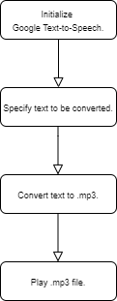

Figure 29: Flowchart of Gesture-to-Speech Algorithm

### Implementation Overview

The flowchart in the previous section assumes there is a pipeline which passes the neural network’s output (as a string) to the appropriate Google Cloud API. The particular Google Cloud API necessary to perform text-to-speech conversion is the Google Voice API. In Python, the Google Text-to-Speech library (imported as “gtts,” an abbreviation of “Google Text-to-Speech”) provides the functions for text-to-speech conversion. Before speech-to-text conversion is performed, the output of the neural network is saved on a text file. This text file will be read through the Numpy library’s “genfromtxt” function and the result will be passed to the “gTTS” function as an argument. The “genfromtxt” function requires the user to specify a data type, so that the contents read from the desired file will be in the user’s desired form. Meanwhile, the “gTTS” function, imported from the Google Text-to-Speech library, will generate a sound file which contains the finished conversion. This sound file will be played through a function from the Playsound library, which is a Python library that is compatible with Microsoft, Linux, and Apple operating systems. If left unmanaged, every finished conversion will initialize a different sound file. This is a problem, as it can clutter up the user’s storage space. As a solution, the “remove” function from the OS library will be used to delete the output file from the hard drive once most of the program has finished executing.

## Implementation of Task 5

### Implementation Flowchart

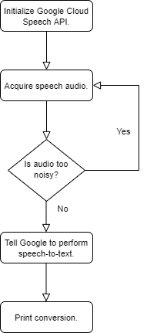

Figure 30: Flowchart of Speech-to-Text Algorithm

### Implementation Overview

The Speech Recognition library is a useful Python library for speech-to-text conversion. Developed by Andrew Zhang, its purpose is to provide an easy-to-use interface with many different speech recognition APIs. Some of these speech recognition APIs include the Microsoft Bing Speech API, the Google Web Speech API, and the IBM Speech-to-Text API. The Speech Recognition library has implemented functions which allow programmers to easily access speech recognition APIs. For example, the “recognize_google” function is used to establish two-way communications with the Google Web Speech API. Sign AI will be using the Google Web Speech API (and, by extension, the “recognize_google” function from the Speech Recognition library) to perform all of its speech-to-text conversion. For normal operation, the Speech Recognition library has one dependency. When using a microphone peripheral, the PyAudio library will be required to access the received audio.

In addition to its base functionality, the Speech Recognition library also offers other helpful features. One of these features involves dealing with noise in audio. Noise can degrade the quality of an audio file to varying degrees. Regardless of the severity of the noise or its type, it will undoubtedly affect the accuracy of the speech recognition software. To account for noise in audio, one can use the “adjust_for_ambient_noise” function in the Speech Recognition library. The “adjust_for_ambient_noise” function increases or decreases the sensitivity of the speech recognition software by manipulating the energy threshold. The energy threshold is used as a cutoff to distinguish speech from noise, where every sound that fails to reach the specified energy threshold will be ignored.

The flowchart in the previous section describes the basic operation of any speech-to-text program. First, code will be written to acquire audio. Afterwards, this audio will be passed to a speech recognition API for processing. The Speech Recognition library has a function for handling noise, so it will be used to maximize the recognizer’s performance. Any recognizer can be used; there is no “ideal” recognizer and, ultimately, the choice of recognizer is up to the user’s preference. After all, the Speech Recognition library not only simplifies the process of communicating with these recognizers, it also provides a breadth of recognizers to choose from. Like with the gesture-to-text output, the output of the recognizer will be printed to a GUI, so care must be taken to ensure that the correct output is displayed. This is where exceptions come into play. An exception is a fundamental coding concept which involves disrupting the flow of a program. Exceptions are typically used to detect something that is undesirable. In the case of speech recognition APIs, instances when the recognizer is unable to recognize speech are undesirable. Ergo, an exception should be written to identify when these instances occur. If the exception is triggered, the user will be prompted to try again. Otherwise, the resulting speech-to-text output will be displayed on the GUI.

## Implementation of Task 6

### Preliminary Considerations

When developing a graphical user interface (or GUI for short), both form and function go hand-in-hand. In terms of form, a GUI should be easy-to-navigate; in terms of function, it should require as little heavy lifting or accommodation from the user as possible. Firstly, a design of a GUI should not be littered with features. There is such a thing as sensory overload, after all. Having more functions usually translates to having more UI elements. This can end up cluttering the user’s screen and make going through the GUI troublesome. Although a GUI that has countless functions sounds like an ideal to strive for, its layout will take careful planning. Secondly, the GUI should be targeted to fulfill a specific purpose. What is the GUI supposed to allow the user to do? In the case of Sign AI, the purpose of the GUI is to acquire and display gesture information. The GUI will package the neural network and the communication features (speech-to-text and text-to-speech) into one. It also will lay the groundwork for establishing the means of receiving and processing data from the user.

### Deciding on GUI Design

It was decided that the GUI for Sign AI will be simple and fulfill 3 basic functions: acquiring sensor data from the Myo armband, sending sensor data to neural network for processing, and acquiring speech data to be converted to text (and vice-versa) by Google APIs. Since the GUI will be written using the Python language, the Tkinter library will be used to develop it. The Tkinter library compiles and adapts the Tk GIU toolkit written in its own language to Python. One main benefit of using Tkinter for GUI development is that it is a cross-platform library, meaning that GUIs spawned from it can be run on Microsoft, Linux, and Apple operating systems. It is also equipped with all the traditional UI elements found in most GUIs such as buttons, drop-downs, and checkboxes.

Typically, buttons are used for executing something at the behest of the user. If the user clicks a button, the user wants to run the function that said button performs. I will be using buttons to give the user a choice to perform a gesture (which will be passed in the form of sensor data to the neural network) or to listen to speech from another party. There will be 2 buttons to encompass these functions, and the buttons will be aptly labeled the “Perform ASL” button and “Listen to Others” button, respectively. In addition to the “Perform ASL” button, a “Speak” button will be created to actualize its output in sound form. This also doubles as a way for the user to check the output, ensuring that their desired gesture was translated before performing the text-to-speech and vocalizing said gesture. We will also require a means of display outputs to the user. Thankfully, fields can be implemented to satisfy this purpose. These fields are filled with the appropriate information once the button is pressed and the function accompanying it is finished executing. A rough draft of the proposed GUI is outlined the figure below.

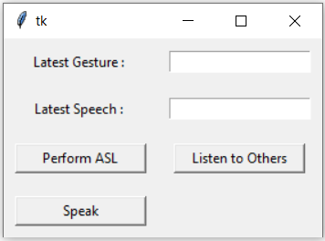

Figure 31: Preliminary design of the GUI

s

### Programming the GUI

The Tkinter library has 2 means of allowing the user to lay out UI elements and position them: pack and grid. The grid method will be used here. In the grid method, the window is treated like it is separated by rows and columns. The “grid configure” function is used to specify the row and column in which a UI element should be placed. If only the row is specified for a UI element, it will take the first available column in that row. For the sake of code organization, object-oriented programming will be used, which means that a class will be created for the GUI. Every class contains with it a set of methods, which, in the realm of procedural programming, are the functions that it is able to perform. It has the special “self” parameter, which allows the overall class to be able to access attributes and methods associated with it. This is unlike procedural programming, where everything contained within a function is local and cannot be accessed outside of said function.

In Python, making GUIs that call long-running processes through button clicks is not straightforward. This is because Tkinter GUIs are not capable of performing asynchronous tasks without outside help. The Tkinter GUI updates itself as well as executes all other user-defined functions or methods in a single thread. The GUI updating itself is last in the pecking order. To make matters worse, if the GUI does not receive the request to update itself within a short period of time, it will become unresponsive, which will prompt the operating system to shut it down and diagnose it. If you call a long-running process, the program will inevitably branch from the main loop where the GUI updates itself to the long-running process that was just called. If your program branches from the main loop for too long, the GUI glitches out and turns unresponsive to any stimulus. Although there is a chance for the GUI to become responsive again, letting it become unresponsive in the first place is a sign of bad programming.

To allow my GUI to call a long-running process, I decided to use the multiprocessing library in conjunction with implementing a queue where outputs from long-running processes are polled periodically. It should be noted that the queue is a FIFO (first in, first out) structure, the opposite of a stack, which is a LIFO (last in, first out) structure. This means that its contents are fetched in the order they were put in. The multiprocessing library will allow my GUI to bypass Python’s global interpreter lock (GIL) and spawn concurrent processes. Recall that the GIL prevents Python from running multiple threads at once. This is effectively dealt with by spawning sub-processes instead. The multiprocessing library is compatible with Windows and Unix systems, but not Apple systems. The queue (which was imported from the Queue library) is made to be a global variable, meaning that it can be accessed and modified by anything in the code space. Methods were written that allow the GUI to put content and retrieve content from the queue. On button click, the multiprocessing library spawns the desired subprocesses. At 10 millisecond intervals, the program checks is the subprocess is still executing. If the subprocess is indeed still executing, the program is instructed to wait until it finishes execution, allowing the GUI to update UI elements without interruption. Once executed, the output of the subprocess is appended to the queue, where it can be fetched. The reason behind the success of this implementation lies in the fact that the GUI is not running the subprocess inside the loop where it is supposed to update UI elements. In this implementation, the only thing that the GUI is responsible for is fetching the output of the subprocesses from the queue. This fetching process takes but a fraction of a second, which means it does not disturb the flow of the main loop and will not render the GUI unresponsive.

1. Conclusion

The goal of Sign AI was to design a translation tool for American Sign Language (ASL). I hoped to use a neural network built through a combination of Tensorflow and the Keras API to recognize different ASL gestures. According to the design requirements set for the project, the number of gesture that the neural network will be capable of recognizing is 100. In addition, the accuracy benchmark for the neural network is 70 percent or higher. The data processed by the neural network must intuitively contain information that it can use to distinguish between all 100 gestures. Therefore, the Myo armband was used to quantify the gestures, measuring EMG data as well as IMU data from the user during the gestures. For each gesture, 100 samples were collected, where 80 samples are set aside for training the neural network while the other 20 samples for testing the neural network. The kind of neural network architecture used for the project is the LSTM network. Its ability to memorize dependencies in time-series data makes it ideal for the project.

To maximize the performance of the neural network, several regularization methods were used. Dropout was used to increase the interpolating power of each layer in the network. Batch normalization was used for smoothing gradients and making them more predictive. Finally, max norm regularization was used to constrain weights to a localized range, preventing them from “exploding” or changing dramatically after every cycle of training. Combined with these regularization methods is an adaptive learning rate optimization algorithm. The adaptive learning rate algorithm calculated ideal learning rates for each weight in the neural network for the sake of speeding up its training and convergence to its solution. The regularization with the optimizer allowed the neural network to perform at a high level, having similar performance for both the training and testing datasets.

Another facet of the Sign AI translation tool are its communication features, which are twofold. The translation tool must allow deaf users – its target demographic – to speak with others as well as understand them. Therefore, it must implement text-to-speech and speech-to-text conversion. All features from the neural network to the text-to-speech and speech-to-text converters will be packaged in a simple GUI using the Tk GUI toolkit adapted in Python. Several problems were resolved before the GUI was fully functional. First, the multiprocessing library was used to sidestep Python’s GIL. Second, a queue was implemented so that the GUI is able to retrieve outputs from the subprocesses spawned by the multiprocessing library.

The project was a relative success, considering the circumstances and constraints. The dataset used for the project was limited, so a deep network and regularization had to be implemented to compensate. The goal of the Sign AI project is to gain understanding of neural networks and learn to use them for various purposes. In the case of Sign AI, the neural network is designed to recognize different ASL gestures. Neural network design is not the only aspect of the project. Since there is a target demographic, the function of the project must cater to their needs. Therefore, a GUI was created so that users are able to interact with the translation tool, allowing them to freely switch between 2 modes, which can be toggled between using 2 buttons. One button picks up speech and converts it to text, while the other button interfaces with the neural network to perform gesture translation. The final product satisfies all the design requirements set forth for the project. By virtue of meeting the design requirements, the project was considered to be successful.

1. Acknowledgements

I would like to thank Dr. Jason Brownlee for his tutorials on machine learning and deep learning algorithms. In addition, I would also like to thank my mentor Dr. Lei Zhang and the Department of Business and Technology for providing me with the materials necessary for me to finish my project.

1. Appendix

## Source Code

### Source Code for GUI

See GitHub link: https://github.com/jpdayrit/Design-of-Sign-AI-An-AI-Based-ASL-Translator/blob/master/Scripts/SignAIFinalized_GUI.py.

### Source Code for Data Logger

See GitHub link: https://github.com/jpdayrit/Design-of-Sign-AI-An-AI-Based-ASL-Translator/blob/master/Scripts/Myo_DataCollect.py.

### Source Code for Speech-to-Text Module

See GitHub link: https://github.com/jpdayrit/Design-of-Sign-AI-An-AI-Based-ASL-Translator/blob/master/Scripts/Speech2Text_GTTS.py.

### Source Code for Text-to-Speech Module

See GitHub link: https://github.com/jpdayrit/Design-of-Sign-AI-An-AI-Based-ASL-Translator/blob/master/Scripts/Text2Speech_GTTS.py.

### Source Code for Interfacing with Neural Network

See GitHub link: https://github.com/jpdayrit/Design-of-Sign-AI-An-AI-Based-ASL-Translator/blob/master/Scripts/contact_NN.py.

1. References

[1] J. Fileccia, “Sensitive care for the deaf: a cultural challenge,” *Creat. Nurs.*, vol. 17, no. 4, pp. 174–179, 2011.

[2] F. G. Bowe, B. T. McMahon, T. Chang, and I. Louvi, “Workplace discrimination, deafness and hearing impairment: The national EEOC ADA research project,” *Work*, vol. 25, no. 1, pp. 19–25, 2005.

[3] C. Lou Garberoglio, S. Cawthon, and M. Bond, “Deaf People and Employment in the United States,” *Washington, DC US Dep. Educ. Off. Spec. Educ. Programs, Natl. Deaf Cent. Postsecond. Outcomes*, 2016.

[4] S. C. Levinson and J. Holler, “The origin of human multi-modal communication,” *Philos. Trans. R. Soc. B Biol. Sci.*, vol. 369, no. 1651, p. 20130302, 2014.

[5] R. E. Mitchell, “How many deaf people are there in the United States? Estimates from the Survey of Income and Program Participation.,” *J. Deaf Stud. Deaf Educ.*, vol. 11, no. 1, pp. 112–119, 2006, doi: 10.1093/deafed/enj004.

[6] National Institutes of Health, “Quick Statistics About Hearing,” 2016. https://www.nidcd.nih.gov/health/statistics/quick-statistics-hearing.

[7] B. Stern, “Inside Myo,” 2016. https://learn.adafruit.com/myo-armband-teardown.

[8] S. Pizzolato, L. Tagliapietra, M. Cognolato, M. Reggiani, H. Müller, and M. Atzori, “Comparison of six electromyography acquisition setups on hand movement classification tasks,” *PLoS One*, vol. 12, no. 10, p. e0186132, 2017.

[9] N. K. Chikkakrishna, T. Tallam, J. S. Pala, S. R. Teja, and D. D. Kumar, “Applying Support Vector Classifiers for Analysis of Pedestrian - Vehicular Conflicts at Unsignalized Crosswalk,” in *2019 IEEE 16th India Council International Conference (INDICON)*, 2019, pp. 1–4, doi: 10.1109/INDICON47234.2019.9029033.

[10] W. Vicars, “First 100 Signs.” https://www.lifeprint.com/asl101/pages-layout/concepts.htm.

[11] C. Mythili and V. Kavitha, “Efficient technique for color image noise reduction,” *Res. Bull. Jordan, ACM*, vol. 1, no. 11, pp. 41–44, 2011.

[12] C. Song, S. Sudirman, and M. Merabti, “A Spatial and Frequency Domain Analysis of the Effect of Removal Attacks on Digital Image Watermarks‖,” Jan. 2010.

[13] T.-C. Lin and P.-T. Yu, “Centroid neural network adaptive resonance theory for vector quantization,” *Signal Processing*, vol. 83, no. 3, pp. 649–654, 2003.

[14] T. Freeman, “What is Imaging Radar?,” [Online]. Available: https://airsar.jpl.nasa.gov/documents/.

[15] D. H. Hubel and T. N. Wiesel, “Shape and arrangement of columns in cat’s striate cortex,” *J. Physiol.*, vol. 165, no. 3, p. 559, 1963.

[16] H. S. Chatterjee, “A Basic Introduction to Convolutional Neural Network,” 2019. https://medium.com/@himadrisankarchatterjee/a-basic-introduction-to-convolutional-neural-network-8e39019b27c4.

[17] V. Bheda and D. Radpour, “Using deep convolutional networks for gesture recognition in American sign language,” *arXiv Prepr. arXiv1710.06836*, 2017.

[18] J. Sutton, “Algorithmia and BERT Language Modeling,” 2020, [Online]. Available: https://algorithmia.com/blog/algorithmia-and-bert-language-modeling.

[19] Colah, “Understanding LSTM Networks,” 2015. https://colah.github.io/posts/2015-08-Understanding-LSTMs/.

[20] R. Pascanu, C. Gulcehre, K. Cho, and Y. Bengio, “How to construct deep recurrent neural networks,” *arXiv Prepr. arXiv1312.6026*, 2013.

[21] M. Hermans and B. Schrauwen, “Training and Analysing Deep Recurrent Neural Networks,” in *Advances in Neural Information Processing Systems 26*, C. J. C. Burges, L. Bottou, M. Welling, Z. Ghahramani, and K. Q. Weinberger, Eds. Curran Associates, Inc., 2013, pp. 190–198.

[22] N. Srivastava, G. Hinton, A. Krizhevsky, I. Sutskever, and R. Salakhutdinov, “Dropout: a simple way to prevent neural networks from overfitting,” *J. Mach. Learn. Res.*, vol. 15, no. 1, pp. 1929–1958, 2014.

[23] S. Ioffe and C. Szegedy, “Batch normalization: Accelerating deep network training by reducing internal covariate shift,” *arXiv Prepr. arXiv1502.03167*, 2015.

[24] S. Santurkar, D. Tsipras, A. Ilyas, and A. Madry, “How does batch normalization help optimization?,” in *Advances in Neural Information Processing Systems*, 2018, pp. 2483–2493.